Healthy Grocery List
 | Vegetables |  |  |  |  | Grains
 |  | Spinach (fresh or frozen) |  |  |  |  | Brown rice
 |  | Broccoli florets |  |  |  |  | Whole wheat bread
 |  | Bell peppers (mixed colors) |  |  |  |  | Rolled oats
 |  | Carrots (whole or baby) |  |  |  |  | Quinoa
 |  | Cucumbers |  |  |  |  | Whole wheat pasta
 |  | Tomatoes (vine or cherry) |  |  |  |  | Barley
 |  | Zucchini |  |  |  |  | Whole grain tortillas
 |  | Sweet potatoes |  |  |  |  | Bulgur
 | Fruits |  |  |  |  | Proteins
 |  | Apples |  |  |  |  | Natural peanut butter (with no sugar)
 |  | Bananas |  |  |  |  | Skinless chicken breast
 |  | Oranges |  |  |  |  | Salmon fillets
 |  | Blueberries |  |  |  |  | Eggs
 |  | Strawberries |  |  |  |  | Greek yogurt (plain)
 |  | Grapes |  |  |  |  | Lentils
 |  | Avocados |  |  |  |  | Chickpeas
 |  | Lemons or limes |  |  |  |  | Tofu
 |  |  |  |  |  |  | 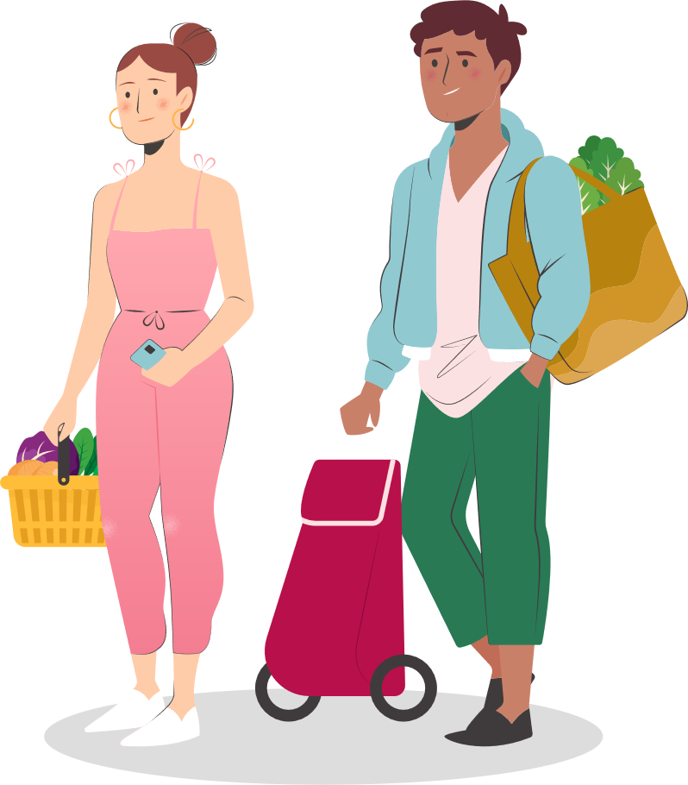
 | Others
 |  | Almonds or mixed nuts
 |  | Fresh herbs (parsley, cilantro, basil)
 |  | Garlic
 |  | Herbal tea
 |  | Dark chocolate (70% cocoa or higher)
 |  | Hummus
 |  | Cottage cheese
 |  | Low-fat milk or plant-based milk
 |  | Olive oil (extra virgin)
 |  | Chia seeds



© Docformats.net. All Rights Reserved.
By downloading or using this template, you agree to comply with the Terms of Use as stated on Docformats.com. Unauthorized distribution is strictly prohibited.

Fonts Used in This Template:
- Sora: https://fonts.google.com/specimen/Sora

