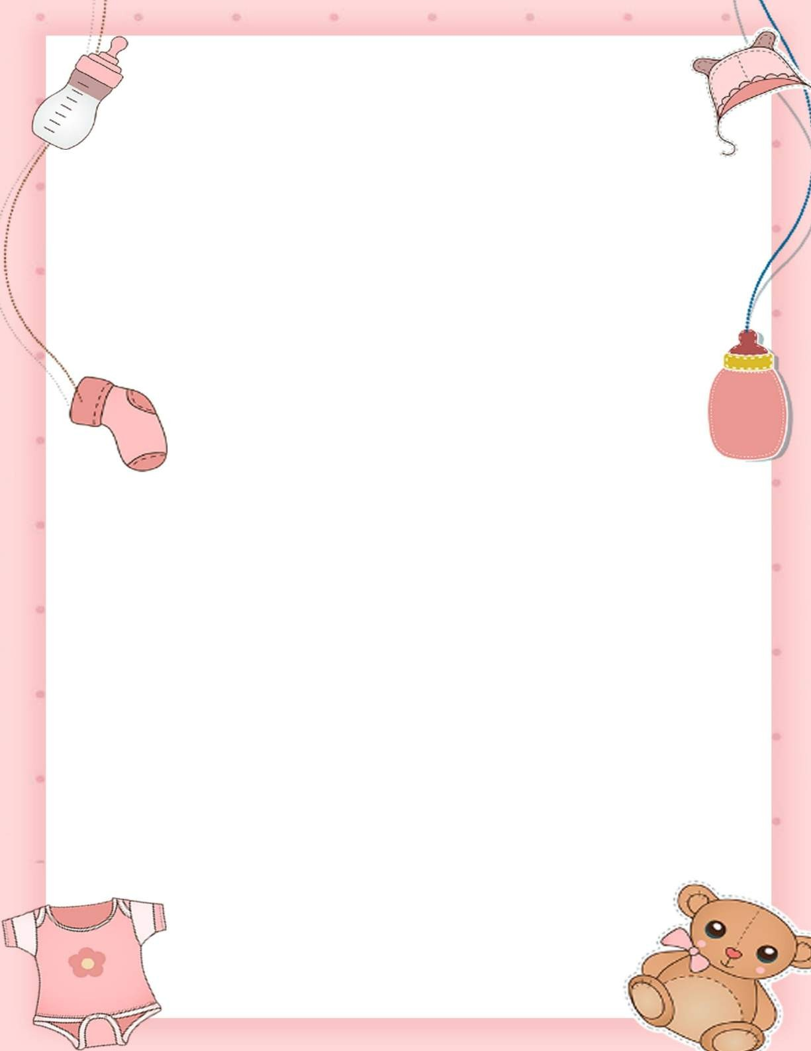
BABY REGISTRY CHECKLIST
- 1-3 washable crib mattress pads
- 2-4 fitted crib sheets
- 4-6 soft, light receiving blankets
- 1-2 heavier blankets
BABY BEDDING
- Baby nail clippers

- Baby thermometer
- Petroleum jelly and sterile gauze First aid kit
HEALTH PRODUCTS
- Changing table
- cushioned changing pay for low dresser
- Diaper pail and liners

- Diaper bag

- Diaper cream

- Unscented baby wipes

- Soft washcloths

- 6-10 dozen cloth
DIAPERING MUST-HAVES
- convertible car seat

- Stroller or infant carrier

- Baby swing or bouncer

- Play yard with bassinet
BABY GEAR
- 4-8 onesies

- 4-8 undershirts

- 4-8 one-piece pajamas

- 2 blanket sleepers

- 1-3 sweaters or jackets

- 1-3 rompers or other dress

- 4-7 socks or booties

- No-scratch mittens

- Bunting bag or fleece suit
BABY CLOTHES
- 10-16 bottles and nipples

- Pump

- Milk storage bags

- Nursing pads

- Nipple cream

- Nursing pillow

- Bottle brush

- Dishwasher basket
FEEDING ESSENTIALS
- Baby bathtub

- Baby shampoo

- Baby soap

- 2-4 soft towels

- Baby hairbrush
BATH ITEMS

