2ND time
Gather ☆ Momogami Twins

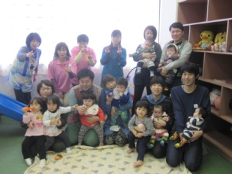
Twins and moms & dads living in the top area
Date: March 14th (Sat) 10: 00-11: 30
Place: Wakuwaku Shinjo, 2nd floor
Target: Twins and moms and dads from about 3 months to 3 years old
(Pre-moms & dads are welcome, of course, younger than ♪)
I want to go shopping, but it's hard to take two people! I want to play with the same number of children! Dad is a nuclear family working. What do you do when taking a bath? Twin childcare is harder than expected. Why don't you talk to moms who have the same problem?
On the day, support center childcare person, home start senior mom will assist. Participation is also enjoyed as there are fun stories such as “storytelling” and “play play”.
Volunteers (home start) will help you if you need to go out, so feel free to contact us!
~ We look forward to ~
Contact: Warasuko Plaza TEL / FAX0233-22-5115
Niiyama: 090-6686-9208 (new.mountain@docomo.ne.jp)

