Boy scout pinewood derby free templates
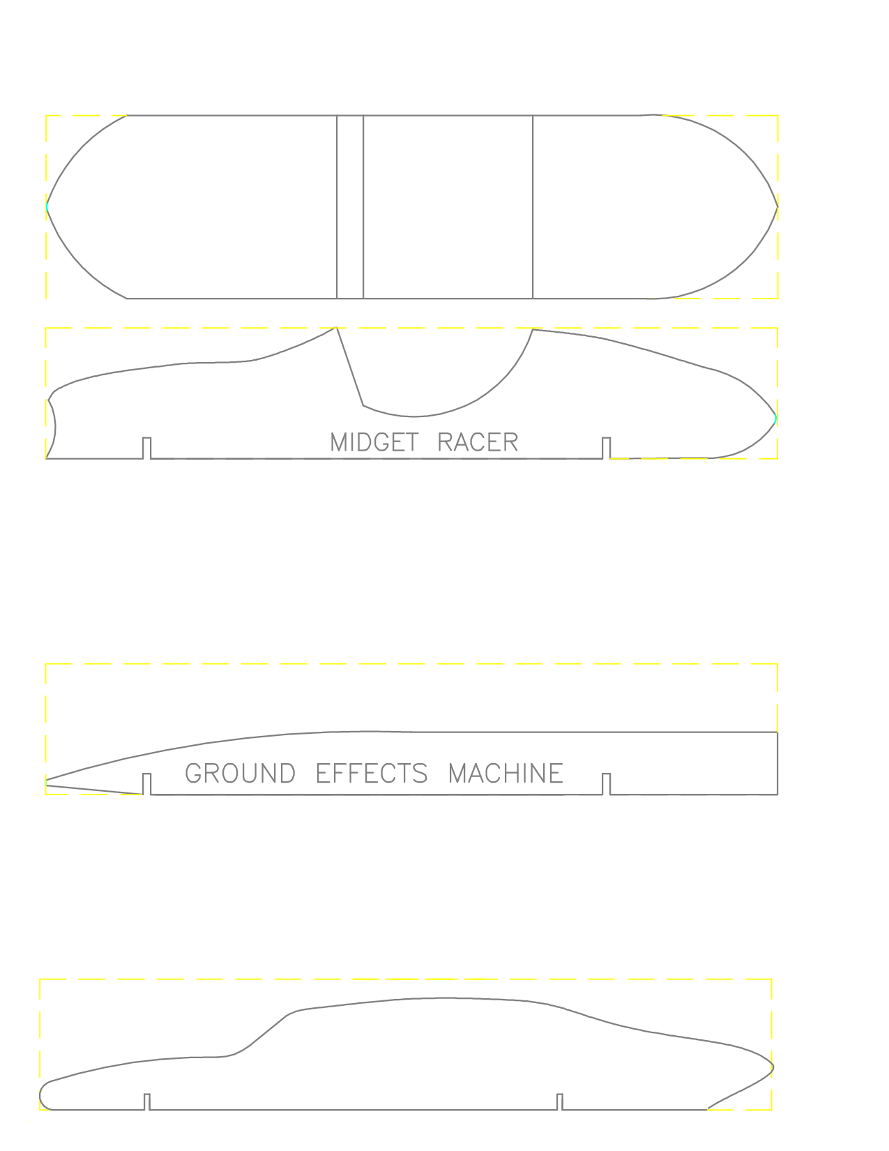

Pinewood derby car templates pdf invitation templates. Pinewood derby free templates pinewood derby car cutting template 4. boy scoutgirl. Pinewood derby free templates pinewood derby car cutting template 4 boy scoutgirl.
Free pinewood derby car templates designs and plans courtesy of derby monkey. 21 cool pinewood derby templates free sle, exle format download! free. Free download speed bus pinewood derby templates. Aids for building a car and running a pinewood derby competition derby certificate template cub scouts. Beginner designs patterns pinewood derby designs patterns.
17 best ideas about pinewood derby templates on pinterest pinewood derby cars, pinewood derby car templates and derby cars. Printable pinewood derby car templates volume 9, issue 9. Free pinewood derby printables. Scout boy cub scout scouts gs derby boyscout ideas scout pinewood. Get best pinewood derby certificate template 123certificate templates certificate template. Pinewood derby speed hot rod template free download. Arrow police car pinewood derby.
Pinewood derby participation certificates google search pinewood derbyboy scouts. Cub scout pinewood derby certificate templates car interior design. G force pinewood derby car kit. Printable pinewood derby car templates pinewood derby secrets. Cyclone top fuel pinewood derby car. Love it will have to print it hot commodity home decor free cub scout printables. 1000 images about pinewood derby cars on pinterest grand prix, pinewood derby and fast cars.
17 best ideas about pinewood derby car templates on pinterest pinewood derby templates, pinewood derby cars and derby cars. Cub bus pinewood derby template design in pdf.
Pinewood derby certificate template. G force pinewood derby car, fastest bsa. You can build this pinewood derby nascar! full car design template included . Atomic wedgie pinewood derby car. Tiger pinewood derby car plan picture.
Pinewood derby speed hot rod template free download. Free pinewood derby car designs templates. Pics photos pinewood derby car templates pdf 0crd0r68. Free pinewood derby car templates to print. Batmobile, skateboard pinewood derby car. Pinewood derby car templates pinewood derby design lightning mcqueen.
Pinewood derby car templates free. Free pinewood derby template by sin customs 001806. Best photos of cub scout invitation template cub scout blue and gold. Free pinewood derby bullet car template pdf. Blank car derby template pdf format download.
Humvee, dragster pinewood derby. You can build this pinewood derby wolf car! full car design template included . Explore pinewood derby cars, boy scouts, and more!. Bacon car awana grand prix / pinewood derby template.
Pinewood car design plan spider photo picture. Alpine district cub scouts pinewood derby certificates. Pinewood derby designs and patterns. Free pinewood derby ferari cars design templates derby talk view topic 2009 parent. But we jazzed it up by making tiny pinewood derby cars ... boyscouts pinterest cars, we and track.
Pinewood derby pinewood derby ideas pinterest cars, grand prix and search. Pinewood derby car design idea.
Ahg pinewood derby g force pinewood derby car ahg pinewood derby pinterest cars, ideas and search. Pinewood derby award ideas boy scoutingpinewood. Pinewood derby certificate template. Pinewood derby car templates printable free pictures. Cub scout pinewood derby award templates.
Fast pinewood derby car design templates pinewood derby car designs. Pinewood derby times newsletter volume 8 issue 10.
Free pinewood derby car design templates. Pinewood derby car racing license. Pinewood derby car design plans. Cool pinewood derby designs on boy scout pinewood derby car designs. Cub scout pinewood derby coloring sheets coloring pages.
Pirate pinewood derby car kit axle holes black. Swiss cheese pinewood derby design. 17 best ideas about pinewood derby car kits on pinterest pinewood derby cars, derby cars and pinewood derby templates. Pinewood derby place printable certificate. Minecraft pinewood derby car with template.

