Direct Deposit Authorization Form
Please print and complete ALL the information below.

Name: ____________________________________________________________

Address: ____________________________________________________________

City, State, Zip: ____________________________________________________________

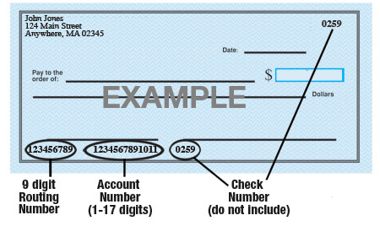

Name of Bank: ____________________________________________________________

Account #: ____________________________________________________________

9-Digit Routing #: ____________________________________________________________

Amount: ◻ $ ____________ ◻ ____________%  or ◻ Entire Paycheck

Type of Account: Checking Savings (Circle One)

Please attach a voided check for each bank account to which funds should be deposited.

[Company Name] is hereby authorized to directly deposit my pay to the account listed above. This authorization will remain in effect until I modify or cancel it in writing.

Employee Signature: ____________________________________________________________

Date: ___________________________

