3.MD.B.3
*This standard is part of a supporting cluster
Standard
Draw a scaled picture graph and a scaled bar graph to represent a data set with several categories. Solve one- and two-step "how many more" and "how many less" problems using information presented in scaled bar graphs. For example, draw a bar graph in which each square in the bar graph might represent 5 pets.

Standard Unpacked
Students should have opportunities reading and solving problems using scaled graphs before being asked to draw one. Work with scaled graphs builds on students’ understanding of multiplication and division.

This standard calls for students first to create a graph. Students should be allowed ample opportunities to create graphs in order to develop various strategies of choosing an appropriate scale, and then determine if the scale they chose was reasonable. In addition to creating a graph, students are then asked to solve one and two-step problems based on the data. Being able to solve problems based on the data requires students to make sense of the graph, analyze it’s data, and provides a context for students.
While exploring data concepts, students should pose a question, collect data, analyze data, and interpret data Students should be graphing data that is relevant to their lives.
Example:
Pose a question: Student should come up with a question. What is the typical genre read in our class? Collect and organize data: student survey
The following graphs provided below all use five as the scale interval, but students should experience different intervals to further develop their understanding of scale graphs and number facts.
Pictographs: Scaled pictographs include symbols that represent multiple units. Below is an example of a pictograph with symbols that represent multiple units. Graphs should include a title, categories, category label, key, and data. How many more books did Juan read than Nancy?
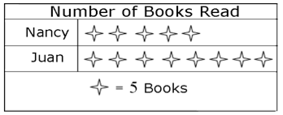

Single Bar Graphs: Students use both horizontal and vertical bar graphs. Bar graphs include a title, scale, scale label, categories, category label, and data.

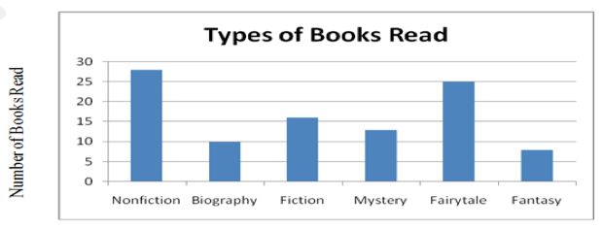
Analyze and Interpret data:
- How many more nofiction books where read than fantasy books?
- Did more people read biography and mystery books or fiction and fantasy books?
- About how many books in all genres were read?
- Using the data from the graphs, what type of book was read more often than a mystery but less often than a fairytale?
- What interval was used for this scale?
- What can we say about types of books read? What is a typical type of book read? (beyond standard)
- If you were to purchase a book for the class library which would be the best genre? Why? (beyond standard)

A scaled picture graph contains a key that indicates what each symbol stands for. When you read data from a scaled picture graph, you need to know the value of each symbol and multiply each symbol by the value or add up the symbols using the values. When reading a bar graph, you compare the lengths of the bars and find out what each bar is worth by reading the scale. The bars in a bar graph do not need to be in numerical order. When you interpret data from picture graphs or bar graphs, you need to focus on which category has more, less or the same amount. This allows you to draw conclusions about the information shown in the graph and make generalizations. It is reasonable to expect students to be comfortable with bar graphs that have a scale of 1, 2, 5, and 10. Some students will also be able to work with scales of 20, 50, or 100.

Students sometimes confuse the meaning of symbols on a graph. A classic example is misunderstanding the key and the value a symbol represents. Begin working with graphs that have a 1-to-1 correlation. Then move to intervals aligned with skip-counting capabilities of students.

Questions/ Activities to check for understanding and increase rigor:
- The set of data describes the ages of a group of people at a family party. 32, 30, 5, 2, 1, 62, 58, 28, 26, 25, 24, 2, 4, 29, 16. Create a graph to display the data. Describe why you chose to construct your graph the way you did.
- The students asked 20 people about their favorite ice cream flavors and wanted to make a bar graph to show their data. What would be a good scale to help organize their bar graph and why?
- A bar graph shows the greatest data point of 45. The lowest data point is 21. How many more votes is the greatest number than the lowest? Model your thinking. Create a graph and a set of data where the greatest point is 45 and the lowest point is 21. Include a brief description of what the data might be about.

 | Level 1  Entering | Level 2  Emerging | Level 3  Developing | Level 4 Expanding | Level 5  Bridging
Domain: Listening | Follow simple oral directions to draw a scaled picture graph  to represent a data set with several  categories using a picture graph template with teacher modeling. (e.g. Draw symbols to represent the units) | Follow two-step oral directions to draw a scaled picture graph  to represent a data set with several  categories using an illustrated example with a partner (e.g. Draw symbols to represent the units. Include a title.) | Follow multi -step oral to draw a scaled picture graph  to represent a data set with several  categories by creating a graph with a partner (e.g. Draw symbols to represent the units. Include a title. Include a key that indicates what  each symbol stands for.) | Follow detailed oral directions to draw a scaled picture graph  to represent a data set with several  categories by creating a graph in a cooperative group.  (e.g. Include a  title, categories, category label, key, and data) | Follow complex oral directions to to draw a scaled picture graph  to represent a data set with several  categories by creating a graph independently. (e.g. Create a picture graph  choosing an appropriate  scale.)

ELD Standard #3: English Language Learners communicate information, ideas, and concepts necessary for academic success in the content area of Mathematics.

