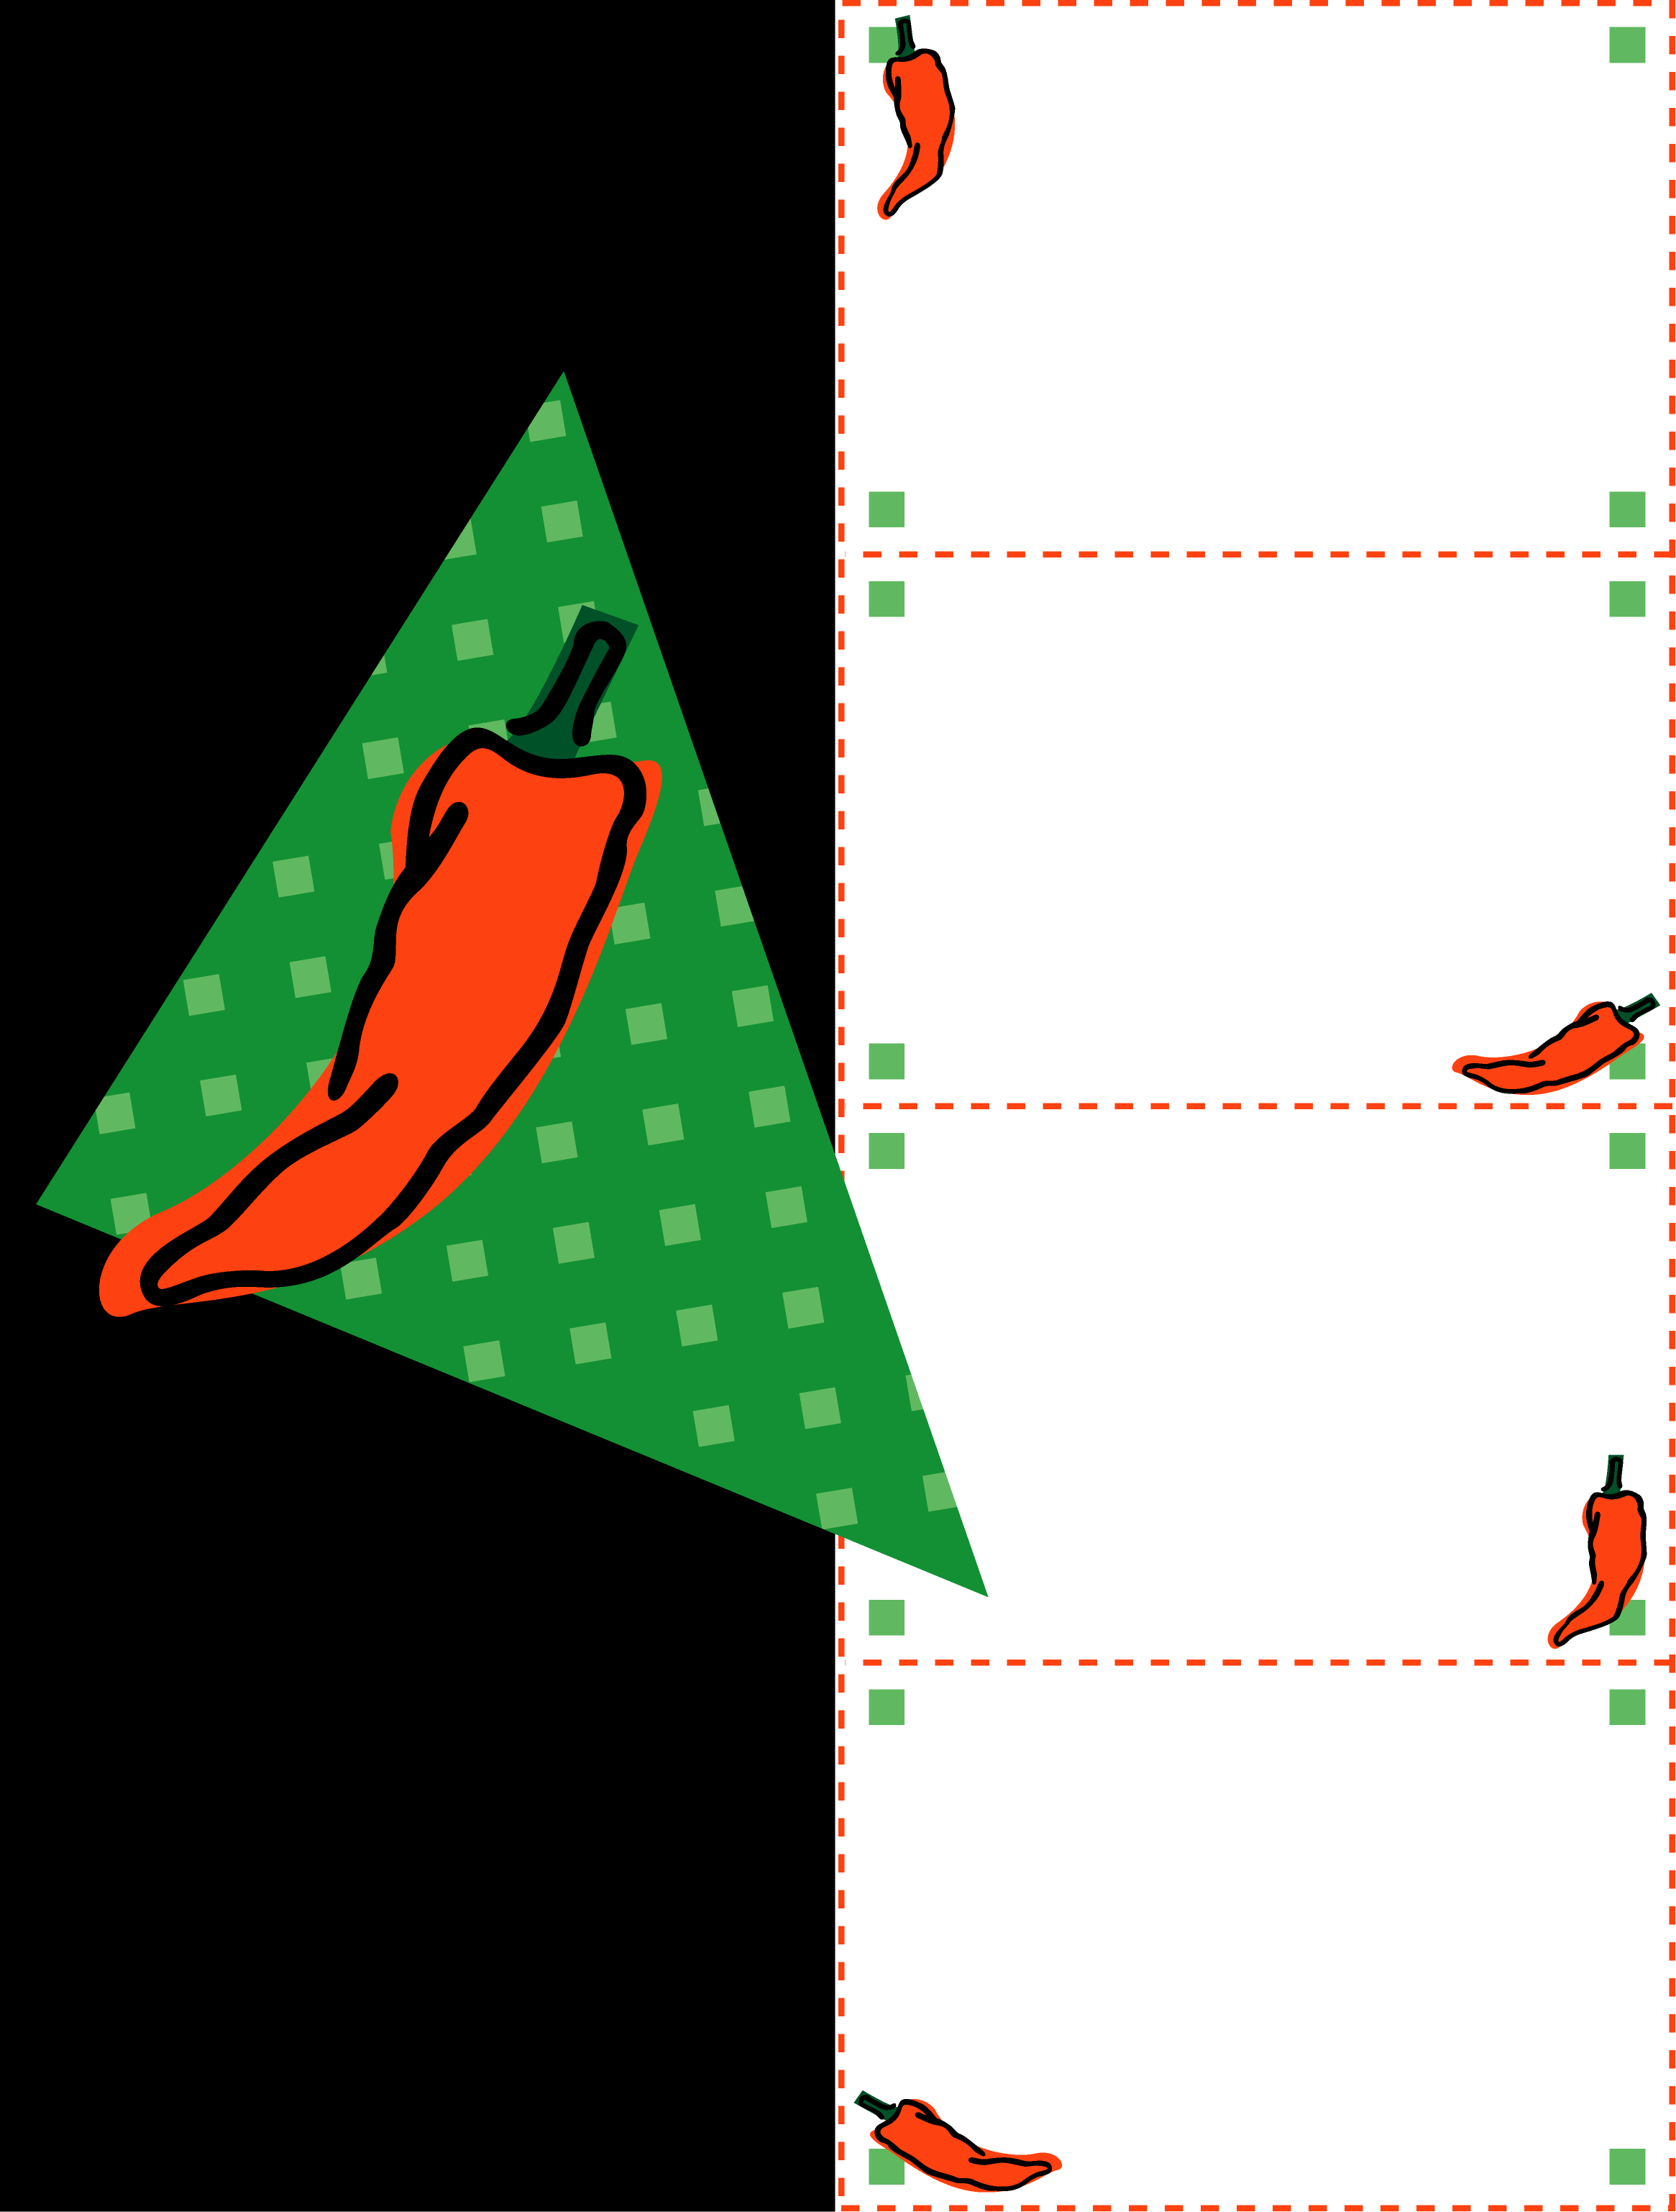

A description of product

(up to 3 lines)

FREE

Coupon restrictions

(up to 3 lines)

Your Name/Location/Phone

(up to 3 lines)

A description of product

(up to 3 lines)

30% OFF

Coupon restrictions

(up to 3 lines)

Your Name/Location/Phone

(up to 3 lines)

A description of product

(up to 3 lines)

15% OFF

Coupon restrictions

(up to 3 lines)

Your Name/Location/Phone

(up to 3 lines)

A description of product

(up to 3 lines)

25% OFF

Coupon restrictions

(up to 3 lines)

Your Name/Location/Phone

(up to 3 lines)

##### RED HOT

##### SAVINGS!

**Click here to insert optional copy**

#### YOUR LOGO HERE IF DESIRED