GENERAL LEDGER

The General Ledger module is the ‘book of record’ for the State of Connecticut. The ‘Actual’ transactions are recorded in the general ledger. The other modules that make up Core-CT create accounting entries that are recorded in that source module and then passed to the general ledger for posting to the appropriate ledger

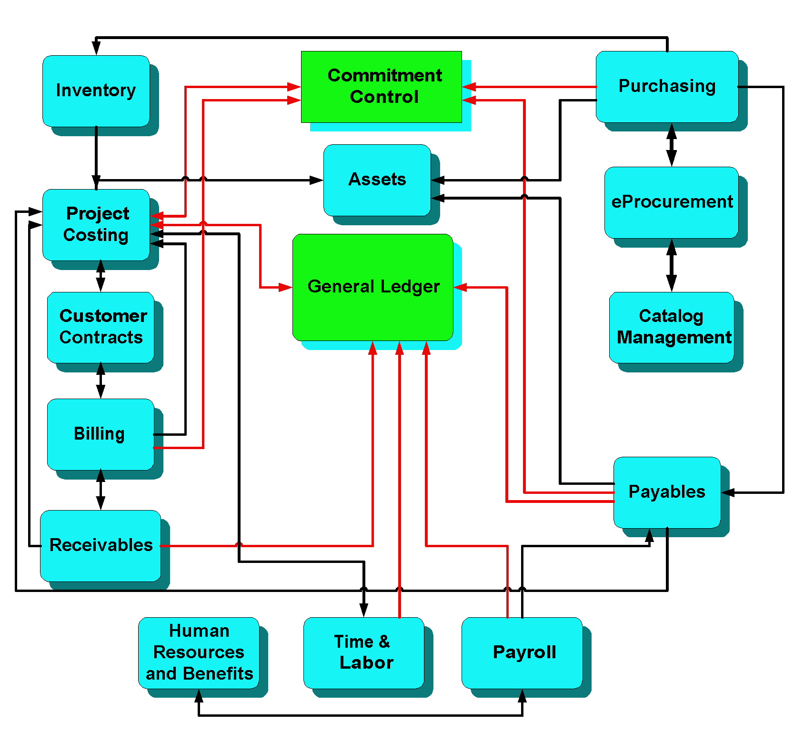

This posted accounting data you can obtain both detail and summary accounting information and produce numerous financial reports for your agency. A description of the tables that make up the General Ledger and Commitment Control appears on page.

Management/Supervisor Review Checklist

Managers and supervisors within the budget and finance areas of their agencies are expected to understand transactions and reporting in the General Ledger and Commitment Control modules. In order to maintain the accuracy of both the general ledger and agency budgets, there are reports and queries that can be run to assist you with the monitoring process.

- Commitment Control > Budget Reports > Budget Status Report

This report is used to monitor and review budget balances. Use this report to ensure that funds are available for anticipated expenditures, such as Telecomm vouchers. Also, ensure that lapsing funds are expended prior to fiscal year end.

The report displays all Commitment Control ledger amounts (budgeted, associated revenue, pre-encumbrance, encumbrance, expense) and the available balance for the budgets you select as of the run date and time.

- Commitment Control > Budget Reports > Negative Budget Report

The Negative Balance report is used to identify budgets that have been exceeded. Agencies can then take appropriate corrective action.

This report displays a listing of negative remaining balances for specific chartfield values or a range of values. The negative balance is calculated by taking the current budget and subtracting all Expenses, Pre-Encumbrances, and Encumbrances for that budget (Budget – (Expenses + Pre-Encumbrances + Encumbrances) = Remaining).

- Commitment Control > Review Budget Exceptions > Budget Exceptions Inquiry

This inquiry is used to review transactions that exceed budget tolerances. Use it to ensure that transactions are properly coded and funds are available for expenditures. It can also be used to monitor the frequency and nature of transaction budget errors.

Agency supervisors and/or managers may have the necessary security to override agency or project budget exceptions.

- EPM Reporting Tools > Query Manager > CT_CORE_FIN_GL_AGY_JRNL_ERRORS

This query will identify any GL Journal Entries that are in Error or Budget Error status. Use it to ensure all necessary entries are valid, pass budget check, and are posted. This can also be used to monitor the frequency and nature of journal entry errors.

Ledger Table Descriptions
General Ledger Tables
Ledger Name | Ledger Description
Modified Accrual  MOD_ACCRL | Expenditures are recognized when AP Vouchers, Payroll, or GL Journal Entries are posted. Revenues are recognized when Bills or GL Journal Entries are posted.  Revenues are offset by auto-generated entries to the Modified Cash ledger (see below), until they are collected. Reports that combine balances from both the MOD_ACCRL and MOD_CASH ledgers are used to report revenues on a cash basis of accounting.  The Accrual ledger (see below), is used to recognize revenues in the accounting period in which they were earned, and to re-allocate expenditures to the accounting period in which they were incurred. Reports that combine balances from both the MOD_ACCRL and ACCRL ledgers are used to report transactions on an accrual basis of accounting.
Modified Cash  MOD_CASH | Used by the Office of the State Comptroller to reverse certain revenue accrual transactions which occur in the Modified Accrual Ledger. The combination of these two ledgers will allow OSC to produce reports which meet the state's legal requirements (e.g. Deferred Revenue from A/R, Accounts Payable Reversals, Salary Reversal).
Accrual  ACCRL | Used by the internal service or enterprise funds to reverse certain transactions which occur in the Modified Accrual ledger. This ledger is used to capitalize the acquisition of assets that are recorded as expenditures in the Modified Accrual ledger. Also, revenues are recognized when earned; expenses when incurred (e.g. depreciation, assets, long term debt). The combination of these two ledgers will allow these agencies to produce reports which meet their reporting requirements.

Commitment Control – Legal Budgets
Legal Budget | Legal Budget Description
Appropriation Ledger Group  KK_APPROP | The Appropriation budget structure is based on Fund, SID, and Agency. It is the highest level for establishing expenditure budget control in Core-CT. It is required for legislative appropriations, i.e. the General Fund and most other non-bond funds. It is created and maintained centrally by OSC.
Allotment Ledger Group KK_ALLOT | The Allotment budget structure is based on Fund, SID, Agency and Budget Reference. It is used to allot portions of appropriations to different time periods that are defined, and to enter new allotments and modify existing ones for changes in allotment amounts. It is required for all General Fund and most other appropriated and non-appropriated Funds. Created quarterly and maintained centrally by OSC based on OPM approved B-1 and B-107.

Bond Budgets
Bond Budget | Bond Budget Description
Authorized Bond  KK_BD_AUTH | The Authorized Bond budget structure is based on Fund, SID, and Agency. It is required for all legislative bond authorizations. It is created and maintained centrally by OSC.
Allocated Bon  KK_BD_ALLC | The Allocated Bond budget structure is based on Fund, SID, and Agency. It is required for all Bond Commission Allocations. It is created and maintained centrally by OSC. Entries to this ledger are triggered by items approved by the bond commission.
Allotted Bond  KK_BD_ALLT | The Allotted Bond budget structure is based on Fund, SID, Agency and Budget Reference. It is required to allot Bond Funds. Budget Reference is used to capture year of bond authorization rather than creating new Fund/SID values annually. Funds are posted based on allotments from OPM.

Agency Budgets - Agency budgets are an expenditure budget structure used to break down Allotment budgets into lower, Department and/or Account levels of detail for controlling spending and/or reporting. Agency Budgets may differ from appropriated amounts. However, budget control will ultimately always reside at Appropriation/Allotment.
- Commitment Control (budget control) ensures that all encumbrances and expenditures are checked against an agency’s budget first.
  - Control budgets
    - Transactions exceeding budget will fail budget check
    - Errors must be corrected
  - Track Budgets
    - Transactions exceeding budget will pass budget check
    - No exception warnings or error messages

Agency Budget | Agency Budget Description
Agency 1  KK_AGY1 | Agency 1 budgets are based on agency defined departments, usually higher levels such as divisions, bureaus, facilities, etc. They may be established as control or track as determined by the Agency. Agency Fiscal Administrative Reviewers must create and maintain agency budgets.
Agency 2  KK_AGY2 | Agency 2 budgets are based on agency defined departments, usually lower levels, such units, cost center, etc. It is not a Control budget. It is used for reporting purposes. Transactions are tracked and recorded at the Department and detailed account level.

Project Budgets - Project budgets are based on agency defined Project ID values. Project Budgets may differ from the Appropriation. However, budget control will ultimately always reside at Appropriation/Allotment. Project IDs ending in NONPROJECT are not included on PRJ budgets. They are tracked on the Agency 1 (KK_AGY1) and/or Agency 2 (KK_AGY2) budget structures.
Project Budget | Project Budget Description
Project 1  KK_PRJ1 | PRJ1 budgets are based on Fund, SID, Agency, and agency-defined Project IDs. Agency Fiscal Administrative Reviewers must create and maintain PRJ1 budgets. They may be established as control or track, as determined by the Agency.
Project 2  KK_PRJ2 | PRJ2 budgets are based on Fund, SID, Agency, and agency defined Project IDs like KK_PRJ1. However, they also record the detail expense Account. Agency Fiscal Administrative Reviewers must create and maintain PRJ2 budgets. They may be established as control or track, as determined by the Agency.
Project 3  KK_PRJ3 | PRJ3 budgets are based on Fund, SID, Agency, and agency defined Project IDs like KK_PRJ1. However, they also record the Chartfield1 value. Agency Fiscal Administrative Reviewers must create and maintain PRJ3 budgets. They may be established as control or track, as determined by the Agency.

Project Costing Budgets - Project Costing budgets are only used by those Agencies that participate in Core-CT Project Costing. Project Budgets may differ from the Appropriation. However, budget control will ultimately always reside at Appropriation/Allotment. Project IDs ending in NONPROJECT are not included on PC budgets. They are tracked on the Agency 1 (KK_AGY1) and/or Agency 2 (KK_AGY2) budget structures. Project IDs that are not part of the Project Costing module may be tracked on PRJ budgets.

Project Costing Budget | Project Costing Budget Description
Project Costing  KK_PC1 | PC1 budgets are based on agency-defined Project Costing Project IDs. Agency Fiscal Administrative Reviewers must create and maintain PC1 budgets. They may be established as control or track, as determined by the Agency.
Project Costing 2  KK_PC2 | PC2 budgets are based on agency-defined Project Costing Project IDs, as well as Fund, SID, and Budget Reference. Agency Fiscal Administrative Reviewers must create and maintain PC2 budgets. They may be established as control or track, as determined by the Agency.
Project Costing 2  KK_PC3 | PC3 budgets are based on agency-defined Project Costing Project IDs, Fund, SID, and Budget Reference, as well as Activity ID. Agency Fiscal Administrative Reviewers must create and maintain PC1 budgets. They may be established as control or track, as determined by the Agency.

Revenue Budgets
Revenue Budget | Revenue Budget Description
Revenue Estimate KK_REV_EST | Used by OPM and OSC to track Revenues for budgeted, lapsing funds by Agency, Revenue Account and Fund. Created and maintained centrally by OSC, this ledger is updated by Billing and Accounts Receivable transactions. It is configured as track only, for reporting purposes.
Associated Revenue KK_ASC_REV | Used by OPM and OSC to track Grant Revenues for non-budgeted, non-lapsing funds by Agency, Revenue Account, Fund, SID and Budget Reference. Created and maintained centrally by OSC, this ledger is updated by Billing and Accounts Receivable transactions. GL Journals and occasional AP entries to revenue may also post to this ledger group. It is configured as track only, for reporting purposes.  OSC reviews the Associated Revenue ledger on a regular basis and Appropriates and Allots any collected accumulated revenue.

KK to GL Reconciliation Tips

- The General Ledger (actual) and Commitment Control (budgets) are made up to two distinct sets of ledgers
  - Commitment Control ledgers all begin with KK
  - The General Ledger is made up of the MOD_CASH, MOD_ACCRL, and ACCRUAL ledgers
- Commitment Control (budget) ledgers contain encumbrances and pre-encumbrances. Encumbrances and pre-encumbrances do not represent finalized transactions so they are not included in the three general ledgers
- Documents that have been successfully budget checked, but are not yet posted to GL will appear in Commitment Control reports and inquiries, but not in general ledger reports
- The General Ledger period closes on or about the 15th of the month
- Budget Structures in Commitment Control post transactions at the roll-up level. GL posts transactions at the detail level. When comparing KK Ledgers to MOD_ACCRL, you must include all the roll-up values in your GL reports
- Include the MOD_CASH Ledger reports and queries to tie bills posted for Refund of Expenditure to Commitment Control. These are posted in General Ledger, but not posted in Commitment Control until payment is received. MOD_CASH Ledger offsets GL to reflect this

Reporting Tools for Reconciliation

- Comprehensive Financial Status Report (CFSR)

CFSRs run monthly for all agencies using Commitment Control (KK) budgets; categories include Personal Services, Other Expenses, and All Other SID’s. This report is run by Fiscal Year and Accounting period, which is valuable when reconciling to General Ledger reports, such as those shown below.

- Budget Status Report

The report displays all Commitment Control ledger amounts (budgeted, associated revenue, pre-encumbrance, encumbrance, expense) and the available balance for the budgets you select as of the run date and time.

- Budget Transaction Detail Report

This report displays the transactions that sum up to Commitment Control (KK) ledger balances. Information can be obtained by Fiscal Year and Accounting Period and should reconcile to the CFSR or Budget Status Reports.

- Flexible Ledger Analysis Report

This report provides account code balances posted to the General Ledger (MOD_ACCRL, MOD_CASH, ACCRUAL). This report can be run for Fund and SID at the Agency level and is a good tool for reconciling to Commitment Control reports.

- General Ledger Activity Report

This report displays the transactions that sum up to General Ledger balances on the Flexible Ledger Analysis Report. It also includes the beginning and ending ledger balances and is used as an excellent investigative tool when researching entries posted to the ledger.

- General Ledger> Review Financial Information> Ledger (Inquiry)
This is an online inquiry that also displays the transactions that sum up to General Ledger balances on the Flexible Ledger Analysis Report. It too is an excellent investigative tool when researching entries posted to the ledger. It is very similar to the General Ledger Activity Report. However, as an online inquiry versus a report, it is more useful when researching only a month or two of history.

- EPM query CT_CORE_FIN_GL_OTHER_DEPT_PS

The query identifies personal services (50000 Account) journal entries in the HR Acctg Line table charged by other departments where the journal line reference (paycheck number) does not exist on the agency's corresponding payroll data for that pay period.

- EPM query CT_CORE_BUDGET_STATUS_REPORT

This query is used to reconcile Budget Balances to GL by Accounting Period. This is valuable, because the Budget Status Report cannot be run by Accounting Period.

- EPM query CT_CORE_FIN_AP_VCHBDCKD_UNPOST

This query is used to identify vouchers that are budget checked and not posted. EPM information is one business day in arrears, so it’s best to use this query after the accounting period has closed.

- CT_CORE_FIN_JRNL_DATCLN_RECON

This query facilitates reconciliation of DATCLEAN entries created to reverse erroneous encumbrances or pre-encumbrances.

Frequently Used General Ledger and Commitment Control Reports

Important: If you are running a report, please be sure to limit the parameters/criteria in your run control. Try running the report for one department and/or one accounting period at first, until you are sure the output is formatted according to your needs.

If you have a report processing for more than 15 minutes, DO NOT simply resubmit the same report request multiple times. You will want to cancel that process and review your criteria. These reports will slow system performance and hold other processes/reports in the queue.

To find a report that is processing, navigate to the Process Monitor page. You may use the search criteria at the top to find any requests that are currently processing. Your User ID should default in. Then select the Run Status of “Processing” and click Refresh. Use the “Details” hotlink on the Process Monitor page to Cancel the report.
Also, using report controls based on User initials is strongly discouraged. The use of report specific information such as the report title and the inclusion of the ledger (for KK reports), i.e. “Budget Status_APPROP”, “Budget Status_ALLOT”, or “Budget Status _PRJ1” saves a great deal of time in report parameter research for the future report processing.

Report Number | Report Name
ctglr317 | Flexible Ledger Analysis  http://www.core-ct.state.ct.us/reports/docs/ctglr317.doc  This report is used to monitor and review account code ledger balances.  The report displays a detail listing of account code balances posted to the General Ledger for single or multiple reporting periods. The run control page provides the user with unique flexibility to select chartfield combinations and to further specify whether they would like the report based on tree nodes or detail values for each chartfield. User can specify balance sheet accounts (assets, liabilities, fund balance) and operating statement accounts (revenues and expenditures). The report can be sorted and subtotaled by chartfield. The report can be run to a PDF or CSV (MS Excel) format. User can also specify one or more ledgers.
gls7002 | General Ledger Activity  http://www.core-ct.state.ct.us/reports/docs/gls7002.doc  The report is used to monitor and review ledger balances and journal line activity. It can be used as a tool to investigate problems and issues discovered when running other General Ledger reports (e.g. Trial Balance).  The report lists the beginning and ending ledger balances by Chartfield combination and account for one or multiple periods. Also lists the detailed journal line activity that is posted against the ledger for the accounting periods that are specified. The report can be sorted and subtotaled by chartfield. It can be run in PDF or CSV (MS Excel) format.
gls8005 | Budget Transaction Detail  http://www.core-ct.state.ct.us/reports/docs/gls8005.doc  This report is used to investigate potential issues and problems found when running summary level reports (e.g. Budget Status).  The report displays a detail listing of all transactions posted to the General Ledger by fiscal year and accounting period. This report is based on the accounting date entered on the Requisition, Purchase Order, Voucher, or Journal Entry. The run control page allows the user to specify the ledger group, transaction type (vouchers, purchases orders, accounting lines), commitment control ledger type, and the specific ledger (e.g. expenses, collected revenue, encumbrances). The user can obtain information on source documents at the level of Fund and SID.
gls8020 | Budget Status  http://www.core-ct.state.ct.us/reports/docs/gls8020.doc  The report displays all Commitment Control ledger amounts (budgeted, associated revenue, pre-encumbrance, encumbrance, expense) and the available balance for the budgets you select as of the run date and time. The run control page provides the user with flexibility to select chartfield combinations and to further specify whether they would like the report based on a range of values or specific values for each chartfield. User can also specify the ledger group (KK_AGY1, KK_ALLOT, KK_APPROP, KK_PROJECT1, etc.). The report can be sorted and subtotaled by chartfield.
ctglr343_ctglr344 | Pre-Encumbrance/Encumbrance Summary Report  http://www.core-ct.state.ct.us/reports/docs/ctglr343_ctglr344.doc  Two different reports can be run from this same page; 1) Pre-Encumbrance Summary, and 2) Encumbrance Summary.  Pre-Encumbrance Summary Report (CTGLR343) displays the status of requisitions (pre-encumbrances) that have been approved and budget checked.  It is reported for each requisition.  Encumbrance Summary Report (CTGLR344) displays the status of purchase orders (encumbrances) that have been approved and budget checked.  It is reported for each outstanding purchase order.
ctglr341_ctglr342 | Pre-Encumbrance/Encumbrance Detail Report  http://www.core-ct.state.ct.us/reports/docs/ctglr341_ctglr342.doc  Two different reports can be run from this same page; 1) Pre-Encumbrance Detail, and 2) Encumbrance Detail.  Pre-Encumbrance Detail Report (CTGLR341) displays the status of requisitions (pre-encumbrances) that have been approved and budget checked. This data is reported for each outstanding requisition Line, Schedule and Distribution line (L/S/D).  Encumbrance Detail Report (CTGLR342) displays the status of purchase orders (encumbrances) that have been approved and budget checked. This data is reported for each outstanding purchase order Line, Schedule and Distribution line (L/S/D).

Other General Ledger Reports

Report Number | Report Name
ctglr128 | Available Cash Trial Balance  http://www.core-ct.state.ct.us/reports/docs/ctglr128.doc  This report is used to monitor and review account code ledger balances.  The report collects information from Cash Accounts for Funds, Agencies, and SIDs, and the data is grouped by Fund, Agency, and SID. The report allows users to process for specific chartfield values, a range of chartfield values, or all Fund, Agency, and SID combinations. For each Fund, Agency, and SID combination summary and detailed information are displayed. The report provides beginning and ending balances, Cash Receipts, Cash Payments, and Cash Transfers.
ctglr315 | Cash Ledger Report  http://www.core-ct.state.ct.us/reports/docs/ctglr315.doc  This report provides cash balance information (prior period YTD, current period transactions, ending balance) and includes the payments, receipts, and transfers that affect the State’s cash account balances. The report can be run by fund, SID and DeptID on a fiscal year and accounting period basis.  This report is used to view monthly cash ledger activity and balances.
ctglr316 | Detail & Summary Revenue  http://www.core-ct.state.ct.us/reports/docs/ctglr316.doc  This report creates a summary or detailed level report capturing the beginning and ending balances, the revenue activity, and the refund of expenditures of the State. The report captures revenue balances based on the Fund and Account specified by the user. It also generates the current period activity and year-to-date amount for that designated chartfield combination. It can be run showing detailed activity, or in summary format.
ctglr7986 | Expenditure Report by Object  http://www.core-ct.state.ct.us/reports/docs/ctglr7986.doc  This report is used to monitor and review account code ledger balances.  The report displays a detail listing of account code balances posted to the General Ledger for single or multiple reporting periods. When multiple reporting periods are selected, the report displays the balances for each period in a separate column (left to right). Due to the potentially large report output (a column for each month) the report is run to CSV (MS Excel) format only.  The run control page provides the user with unique flexibility to select chartfield combinations and to further specify whether they would like the report based on tree nodes or detail values for each chartfield. User can specify expenditure accounts only. The report can be sorted and subtotaled by chartfield.
fin2001 | Journal Entry Detail  http://www.core-ct.state.ct.us/reports/docs/fin2001.doc  This report is used to investigate potential problems with journal accounting entries.  This report displays all journals (e.g. AR, AP, SSJ, ONL, PC) posted to the General Ledger for a specific date(s) or range of reporting periods. The user can obtain information on source documents such as Journal ID, Journal Status (e.g. posted/unposted, posted date, journals with errors, and journals which need editing), Account Description, Chartfield Description, Debit and Credit entries, and if a Reversing Entry was done.
gls7003 | General Ledger Summary  http://www.core-ct.state.ct.us/reports/docs/gls7003.doc  The report is used to monitor and review ledger balances and journal line activity. It is a tool to investigate problems and issues discovered when running other General Ledger reports (e.g. Trial Balance).  The report displays the beginning and ending ledger balances with summary ledger activity by a selected Chartfield combination for a year to date period. The summary ledger activity is a list of journal lDs for the unique chartfield combination and period specified. The report can be sorted by chartfield. The report is available in PDF or CSV (MS Excel) format.
gls7012 | Trial Balance  http://www.core-ct.state.ct.us/reports/docs/gls7012.doc  This report is used to review expenditures posted to the General Ledger by Account and Special ID, for a cumulative period, by fiscal year. The report example (last page) is sorted and sub-totaled by account.

Other Commitment Control Reports

Report Number | Report Name
ctglr118 | Negative Balance Report  http://www.core-ct.state.ct.us/reports/docs/ctglr118.doc  The Negative Balance report is used to identify budgets that have been exceeded. Agencies can then take appropriate corrective action.  This report displays a listing of negative remaining balances for specific chartfield values or a range of values. The negative balance is calculated by taking the current budget and subtracting all Expenses, Pre-Encumbrances, and Encumbrances for that budget (Budget – (Expenses + Pre-Encumbrances + Encumbrances) = Remaining). The report can also be subtotaled by chartfield. The report can be run in a PDF format or CSV (MS Excel) format.
ctglr122 | Federal Program Appropriations  http://www.core-ct.state.ct.us/reports/docs/ctglr122.doc  This report can only be run for the Appropriation Ledger.  The report is used to monitor and review budgetary activity for Federal Grants by allowing users to specify a range of CFDA numbers within a Federal Fund. It can be used as a tool to validate against other General Ledger reports (e.g. Trial Balance, Expenditure Detail, and GL Activity).  The report shows the carry forward, adjustments to appropriation, total appropriation, expenditures, and continued appropriation, subtotaled by SID for a CFDA or range of CFDAs. The report can be sorted and subtotaled by chartfield. It runs in both PDF and CSV (MS Excel) format simultaneously.
ctglr311 | Trial Balance of Appropriation  http://www.core-ct.state.ct.us/reports/docs/ctglr311.doc  This report can only be run for the Appropriation Ledger.  This report is used to create a summary level report containing budget versus actual information on a monthly/yearly basis. The report is a trial balance of appropriations by agency. It will allow the users to group the data by Budget Period, Fund, SID, and Department (Agency).

Frequently Used Job Aids

Budget Spreadsheet Journal Entry
http://www.core-ct.state.ct.us/financials/gl/doc/budget_spreadsheet_journal_entry.doc
General Ledger Spreadsheet Journal Entry
http://www.core-ct.state.ct.us/financials/gl/doc/spreadsheet_journal_entry.doc
Online General Ledger Journal Entry
http://www.core-ct.state.ct.us/financials/gl/doc/spreadsheet_journal_entry.doc
General Ledger / Payroll Reconciliation
http://www.core-ct.state.ct.us/financials/gl/doc/gl_pr_reconcile.doc
Month End Closing Guidelines
http://www.core-ct.state.ct.us/financials/ar/doc/mthnd_cls_gdlns.doc
How to Run the Comprehensive Financial Status Report
http://www.core-ct.state.ct.us/financials/gl/doc/how_to_run_cfsr.doc

The Complete List of Manager Guides
http://www.core-ct.state.ct.us/financials/mgr/Default.htm

Accounts Payable
Accounts Receivable
Asset Management
Billing
Enterprise Performance Management (EPM)
General Ledger / Commitment Control
Help Desk
Inventory
Project Costing / Customer Contracts
Supply Chain

