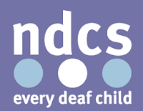
Local Groups T-shirts
Order form

You can order branded T-shirts, polo shirts and black fleeces for your local group. These have been designed by the NDCS brand team, and would have the name of your group printed on the front and back.

NDCS cover the cost of the printing screens and delivery, meaning that you only need to cover the cost of the garments.

Plus, for local groups attending the National Councils, you can receive your first 5 T-shirts absolutely free!

To order, simply complete this form and return to localgroups@ndcs.org.uk

Local group name – please write it how would you like it to be displayed on your T-shirt
Contact name
Delivery address

Please indicate how many you would like to order of each size:

 | S | M | L | XL | XXL
Adult T-Shirt (£6.48)
Child T-Shirt (£5.94)
Adult polo shirt (£9.18)
Adult fleece (£25.14)

Prices are cheaper if you order more than 10 of one type of garment! Ask the local groups team for more information.

